Week-7: React HandsOn
9.ReactJS-HOL HandsOn
Question:
Create a React Application named “cricketapp” with the following components:
- ListofPlayers
- Declare an array with 11 players and store details of their names and scores using the map feature of ES6
- Filter the players with scores below 70 using arrow functions of ES6.
- IndianPlayers
  - Display the Odd Team Player and Even Team players using the Destructuring features of ES6
  - Declare two arrays T20players and RanjiTrophy players and merge the two arrays and display them using the Merge feature of ES6
Display these two components in the same home page using a simple if else in the flag variable.
Answer:
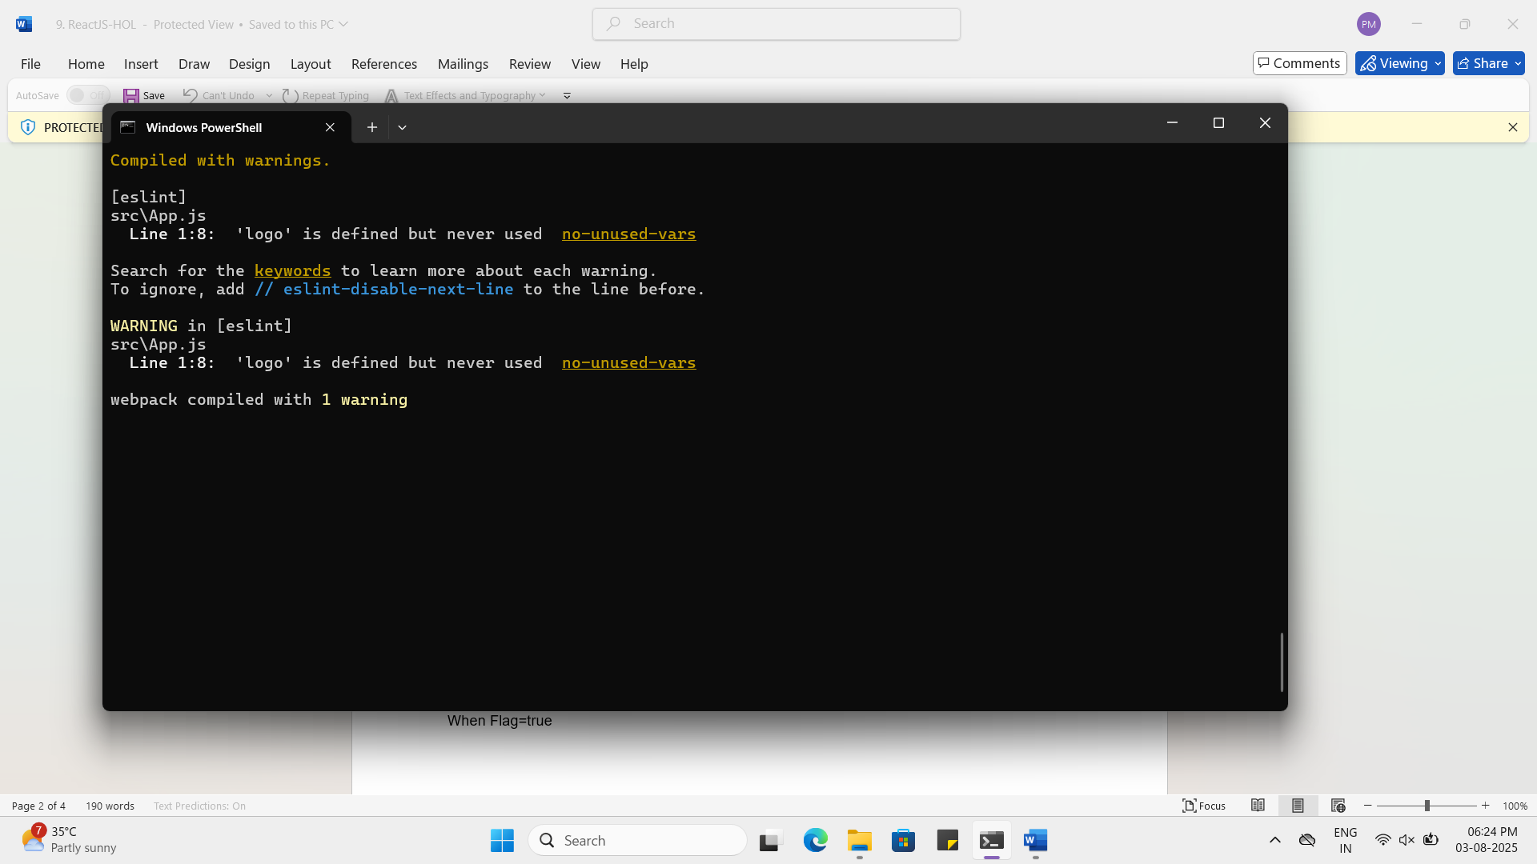
When flag is true:
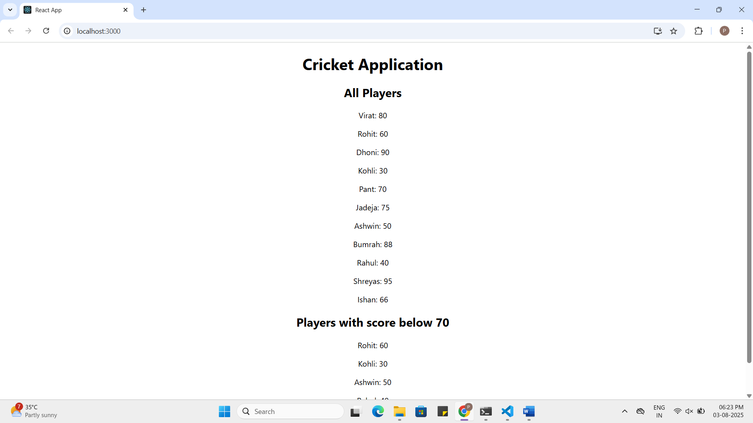

When flag is false:
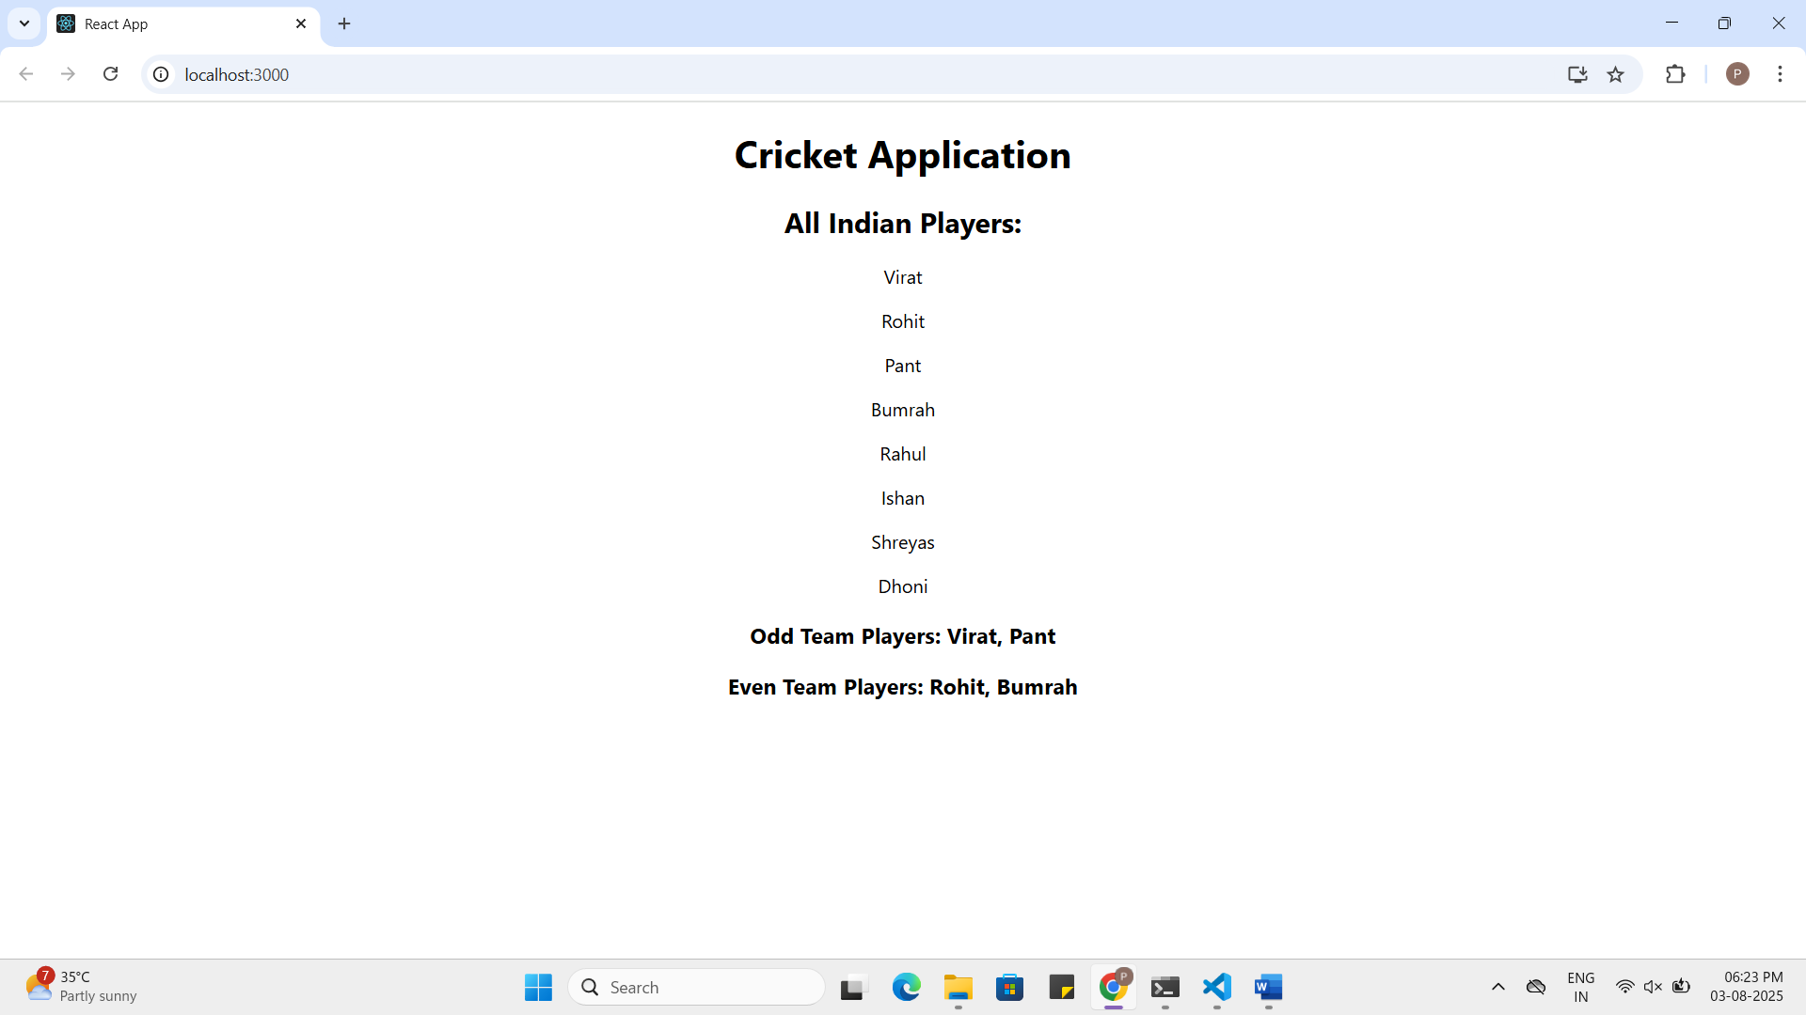

ListofPlayers.js:
import React from 'react';

const ListofPlayers = () => {
const players = [
{ name: "Virat", score: 80 },
{ name: "Rohit", score: 60 },
{ name: "Dhoni", score: 90 },
{ name: "Kohli", score: 30 },
{ name: "Pant", score: 70 },
{ name: "Jadeja", score: 75 },
{ name: "Ashwin", score: 50 },
{ name: "Bumrah", score: 88 },
{ name: "Rahul", score: 40 },
{ name: "Shreyas", score: 95 },
{ name: "Ishan", score: 66 },
];

const below70 = players.filter(player => player.score < 70); // Arrow function

return (
<div>
<h2>All Players</h2>
{players.map((player, index) => (
<p key={index}>{player.name}: {player.score}</p>
))}
<h2>Players with score below 70</h2>
{below70.map((player, index) => (
<p key={index}>{player.name}: {player.score}</p>
))}
</div>
);
};

export default ListofPlayers;
IndianPlayers.js:
import React from 'react';

const IndianPlayers = () => {
const T20players = ["Virat", "Rohit", "Pant", "Bumrah"];
const RanjiPlayers = ["Rahul", "Ishan", "Shreyas", "Dhoni"];

// Merge feature
const allPlayers = [...T20players, ...RanjiPlayers];

// Destructuring
const [odd1, even1, odd2, even2] = allPlayers;

return (
<div>
<h2>All Indian Players:</h2>
{allPlayers.map((player, index) => (
<p key={index}>{player}</p>
))}

<h3>Odd Team Players: {odd1}, {odd2}</h3>
<h3>Even Team Players: {even1}, {even2}</h3>
</div>
);
};

export default IndianPlayers;

10.ReactJS-HOL HandsOn
Question:
Create a React Application named “officespacerentalapp” which uses React JSX to create elements, attributes and renders DOM to display the page.

Create an element to display the heading of the page.
Attribute to display the image of the office space
Create an object of office to display the details like Name, Rent and Address.
Create a list of Object and loop through the office space item to display more data.
To apply Css, Display the color of the Rent in Red if it’s below 60000 and in Green if it’s above 60000.

Answer:
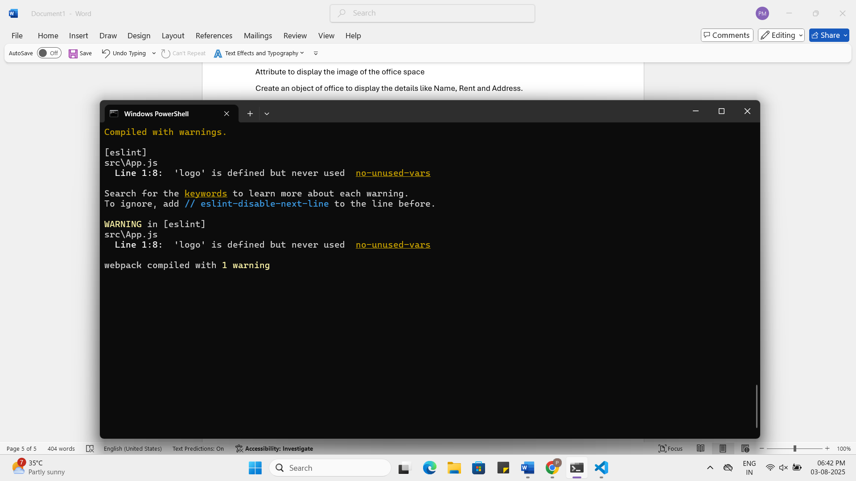
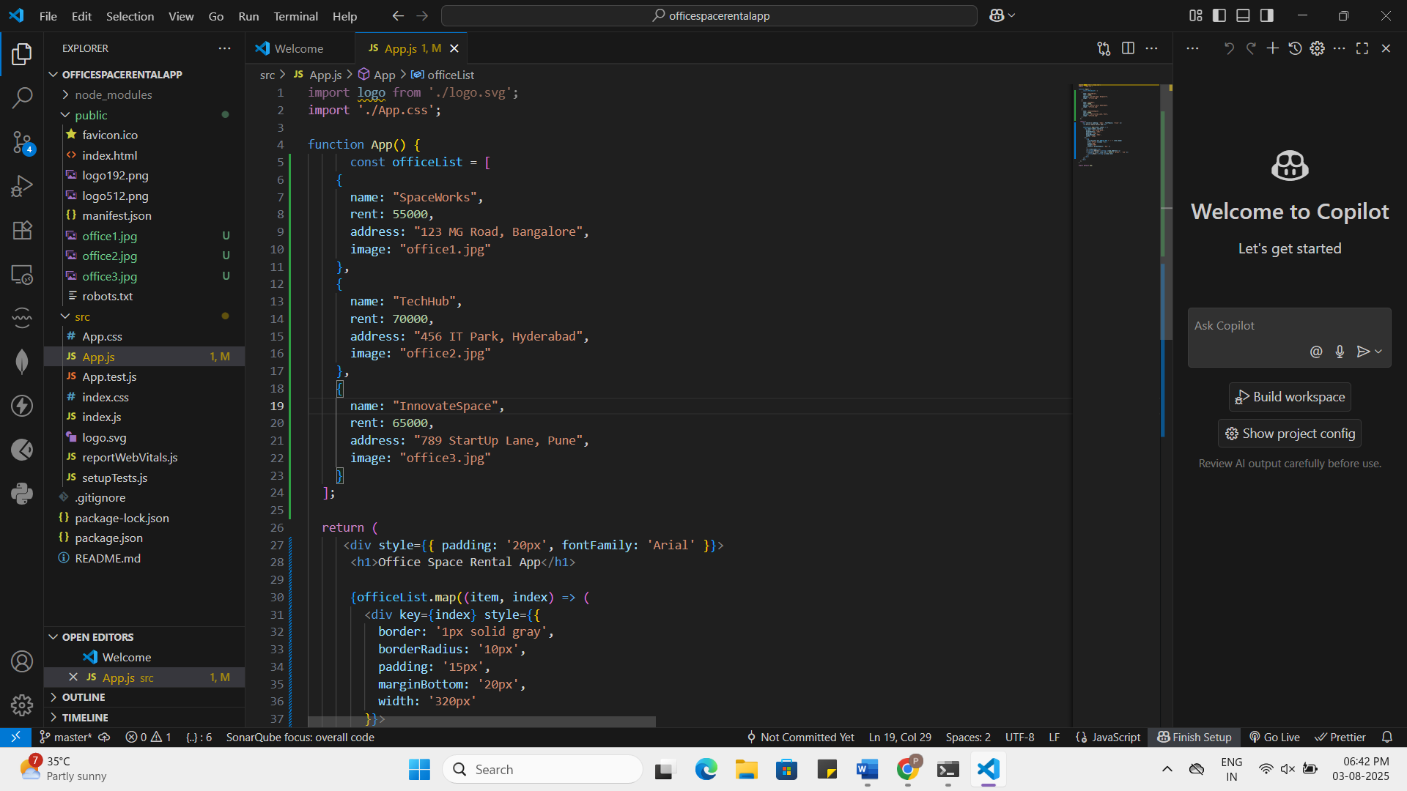

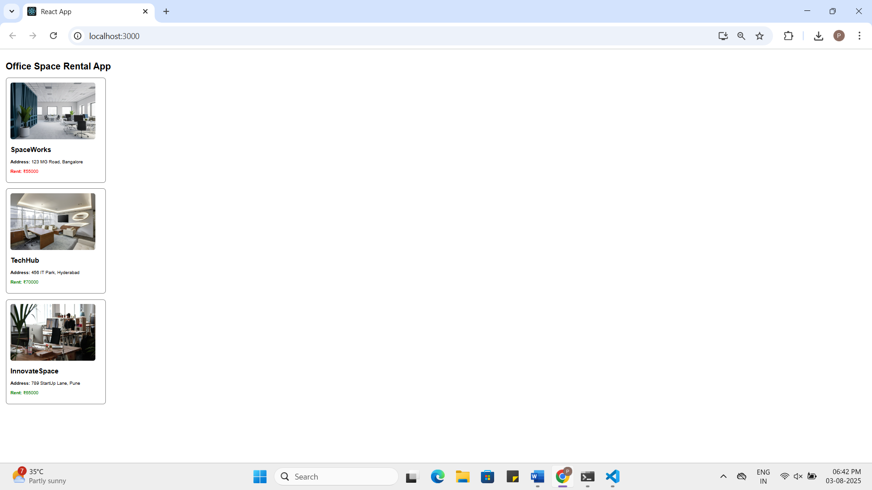

App.js:
import logo from './logo.svg';
import './App.css';

function App() {
const officeList = [
{
name: "SpaceWorks",
rent: 55000,
address: "123 MG Road, Bangalore",
image: "office1.jpg"
},
{
name: "TechHub",
rent: 70000,
address: "456 IT Park, Hyderabad",
image: "office2.jpg"
},
{
name: "InnovateSpace",
rent: 65000,
address: "789 StartUp Lane, Pune",
image: "office3.jpg"
}
];

return (
<div style={{ padding: '20px', fontFamily: 'Arial' }}>
<h1>Office Space Rental App</h1>

{officeList.map((item, index) => (
<div key={index} style={{
border: '1px solid gray',
borderRadius: '10px',
padding: '15px',
marginBottom: '20px',
width: '320px'
}}>
<img
src={process.env.PUBLIC_URL + '/' + item.image}
alt={`Office ${index + 1}`}
width="300"
height="200"
style={{ borderRadius: '8px' }}
/>
<h2>{item.name}</h2>
<p><strong>Address:</strong> {item.address}</p>
<p style={{ color: item.rent > 60000 ? 'green' : 'red' }}>
<strong>Rent:</strong> ₹{item.rent}
</p>
</div>
))}
</div>
);
}

export default App;

11.ReactJS-HOL HandsOn
Question:
Create a React Application “eventexamplesapp” to handle various events of the form elements in HTML.
- Create “Increment” button to increase the value of the counter and “Decrement” button to decrease the value of the counter. The “Increase” button should invoke multiple methods.
  - To increment the value
  - Say Hello followed by a static message.

- Create a button “Say Welcome” which invokes the function which takes “welcome” as an argument.
- Create a button which invokes synthetic event “OnPress” which display “I was clicked”
Create a “CurrencyConvertor” component which will convert the Indian Rupees to Euro when the Convert button is clicked.
Handle the Click event of the button to invoke the handleSubmit event and handle the conversion of the euro to rupees.

Answer:
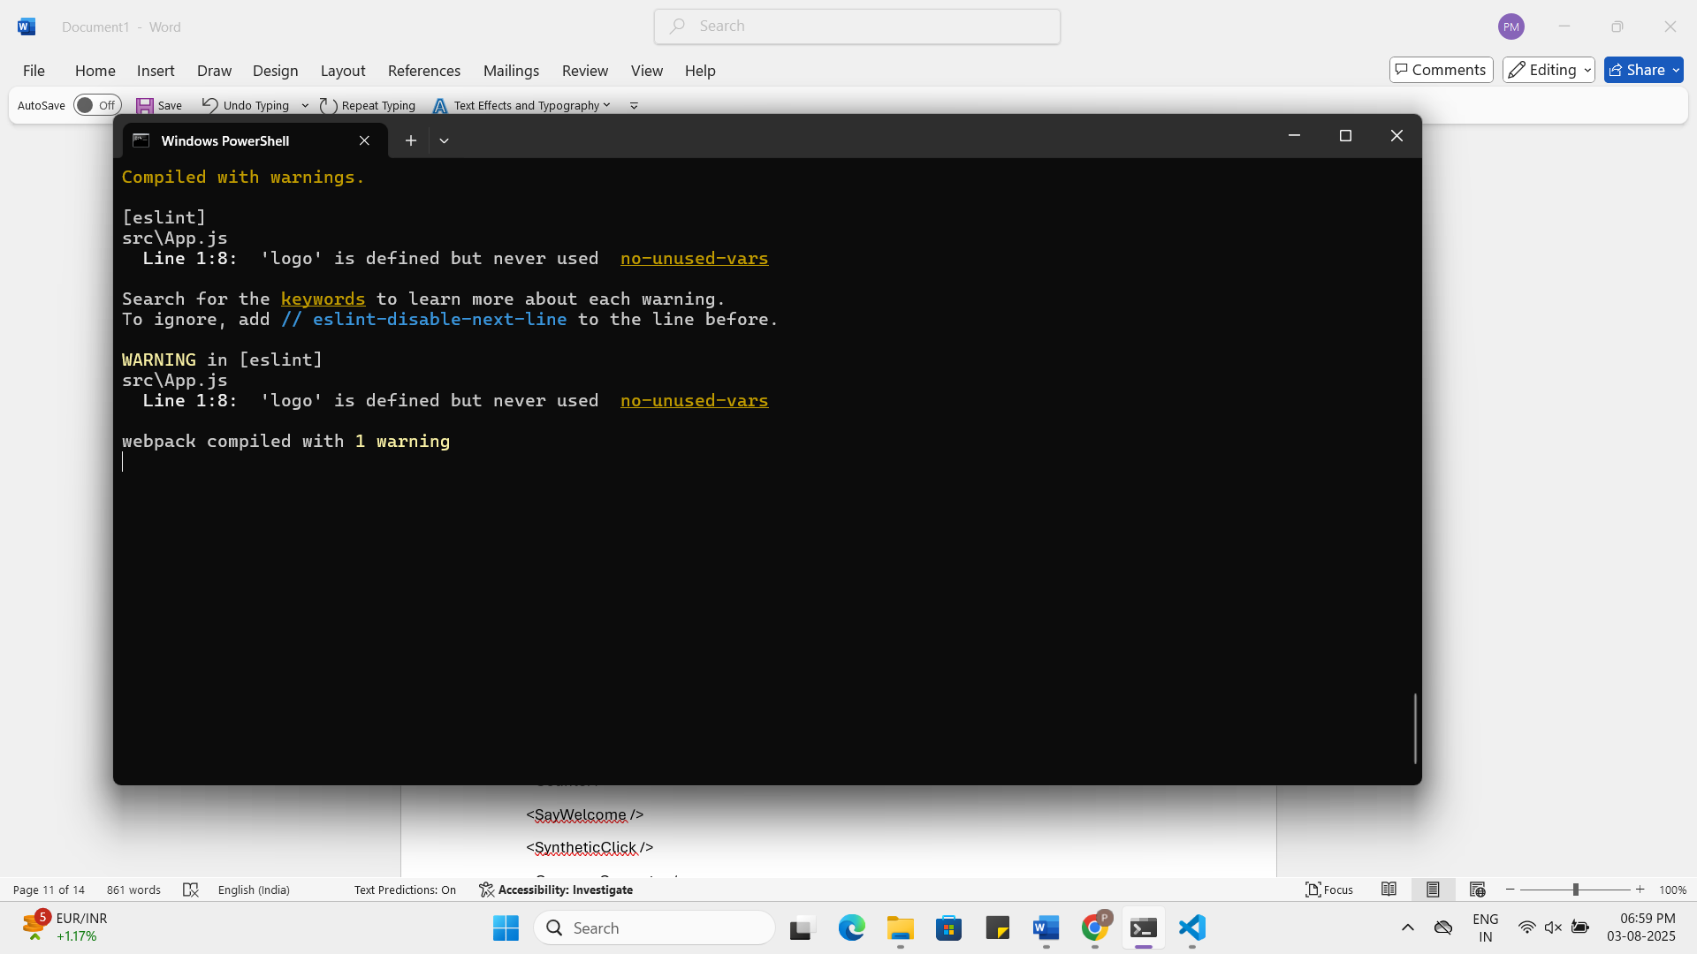
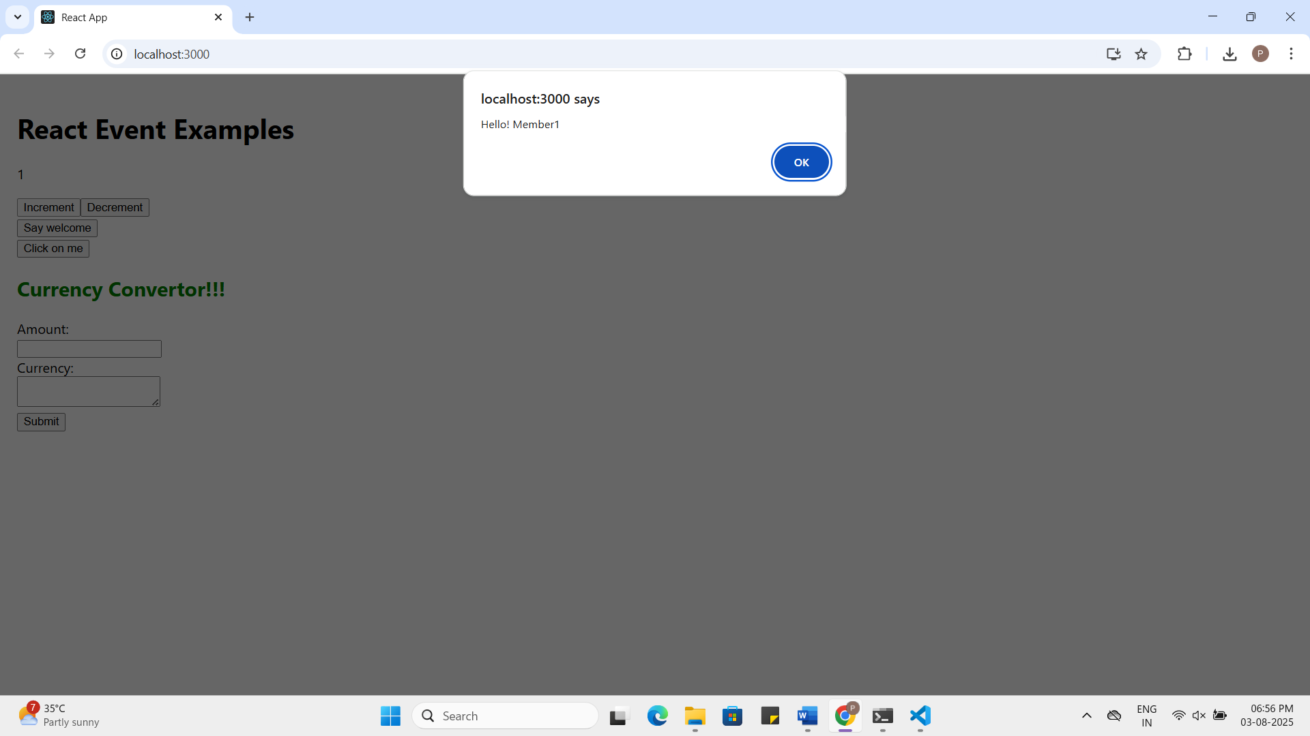

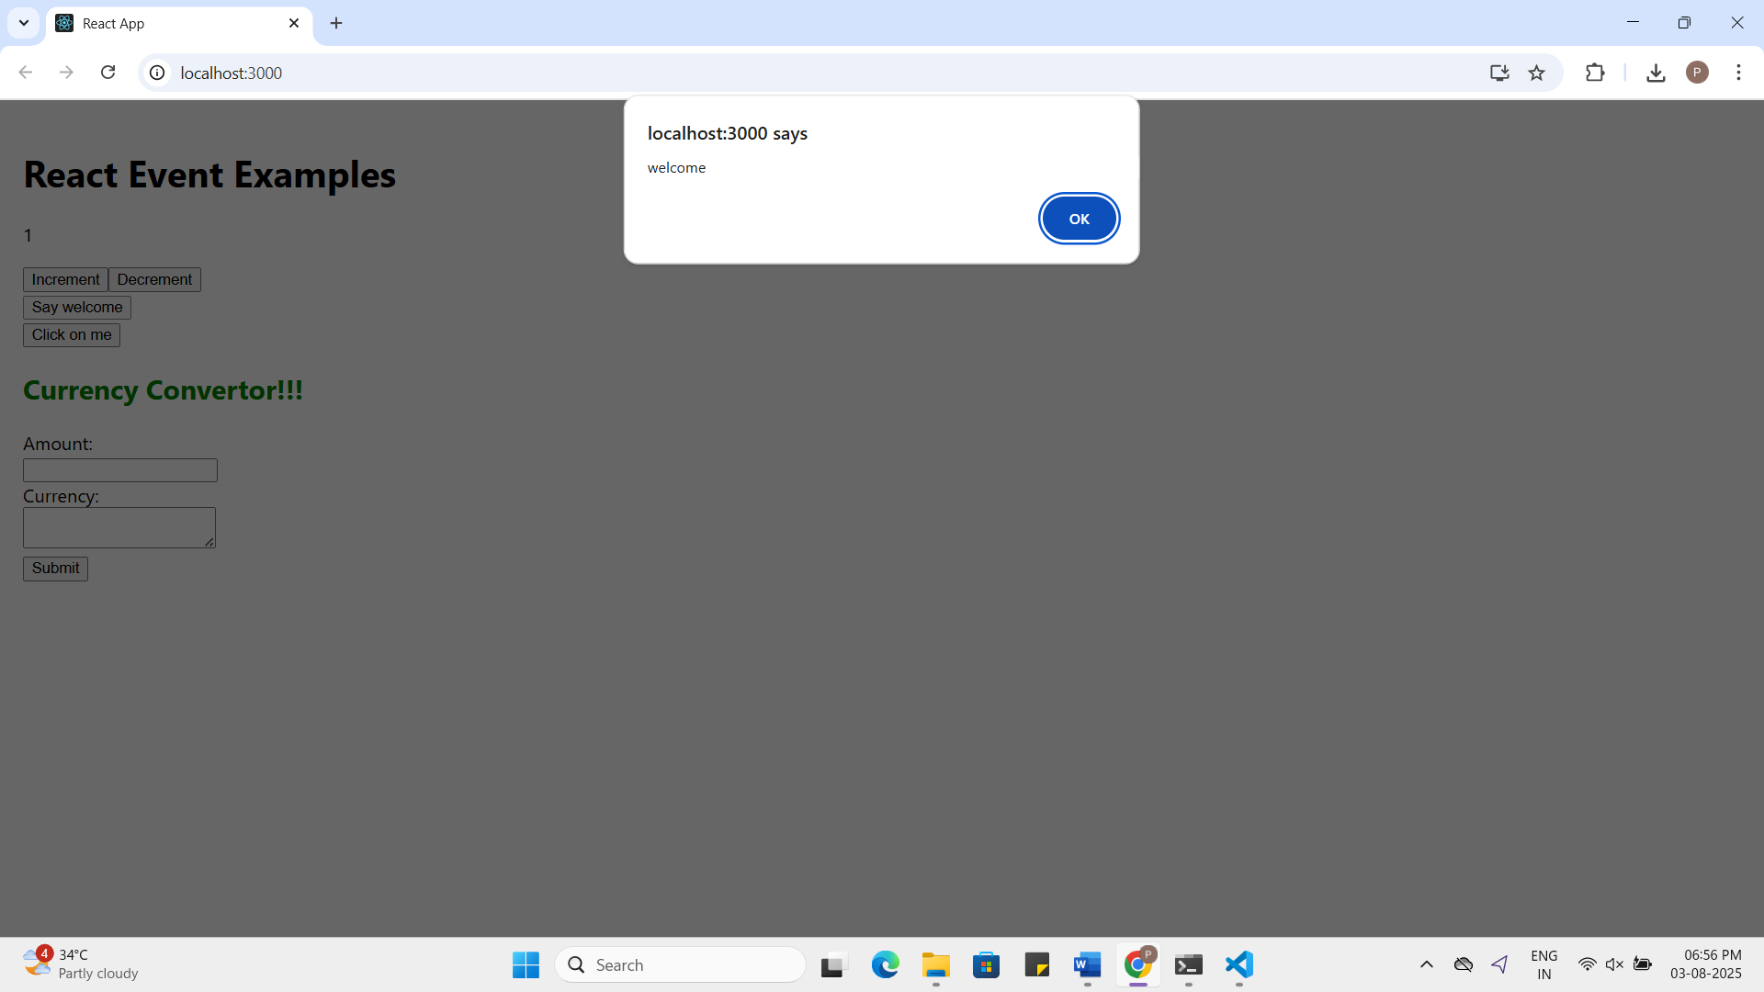
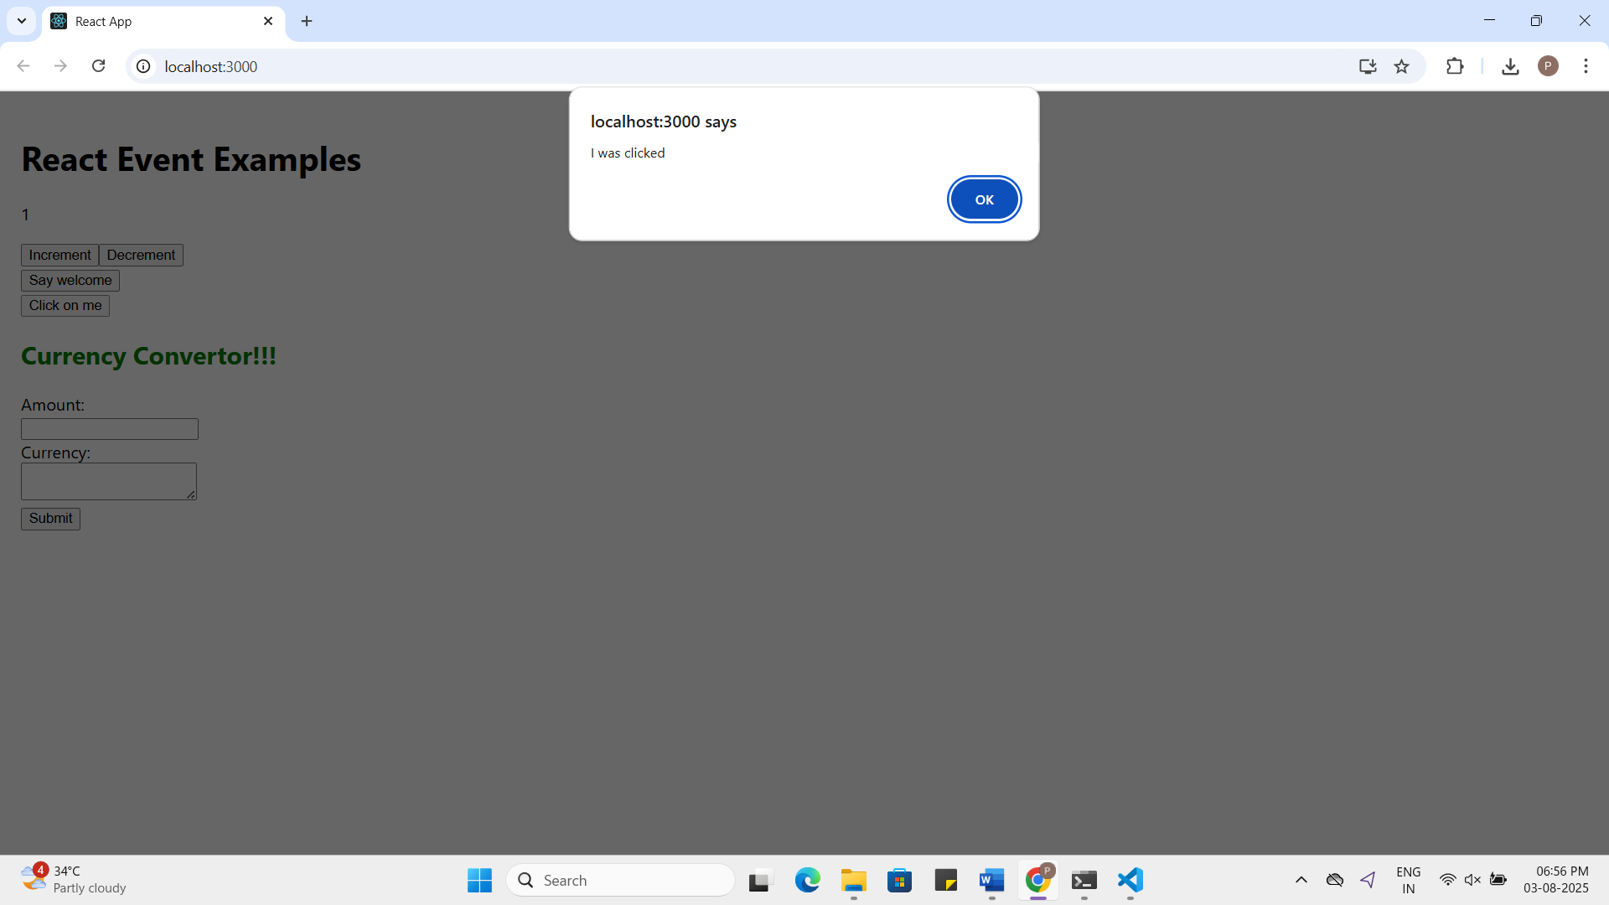
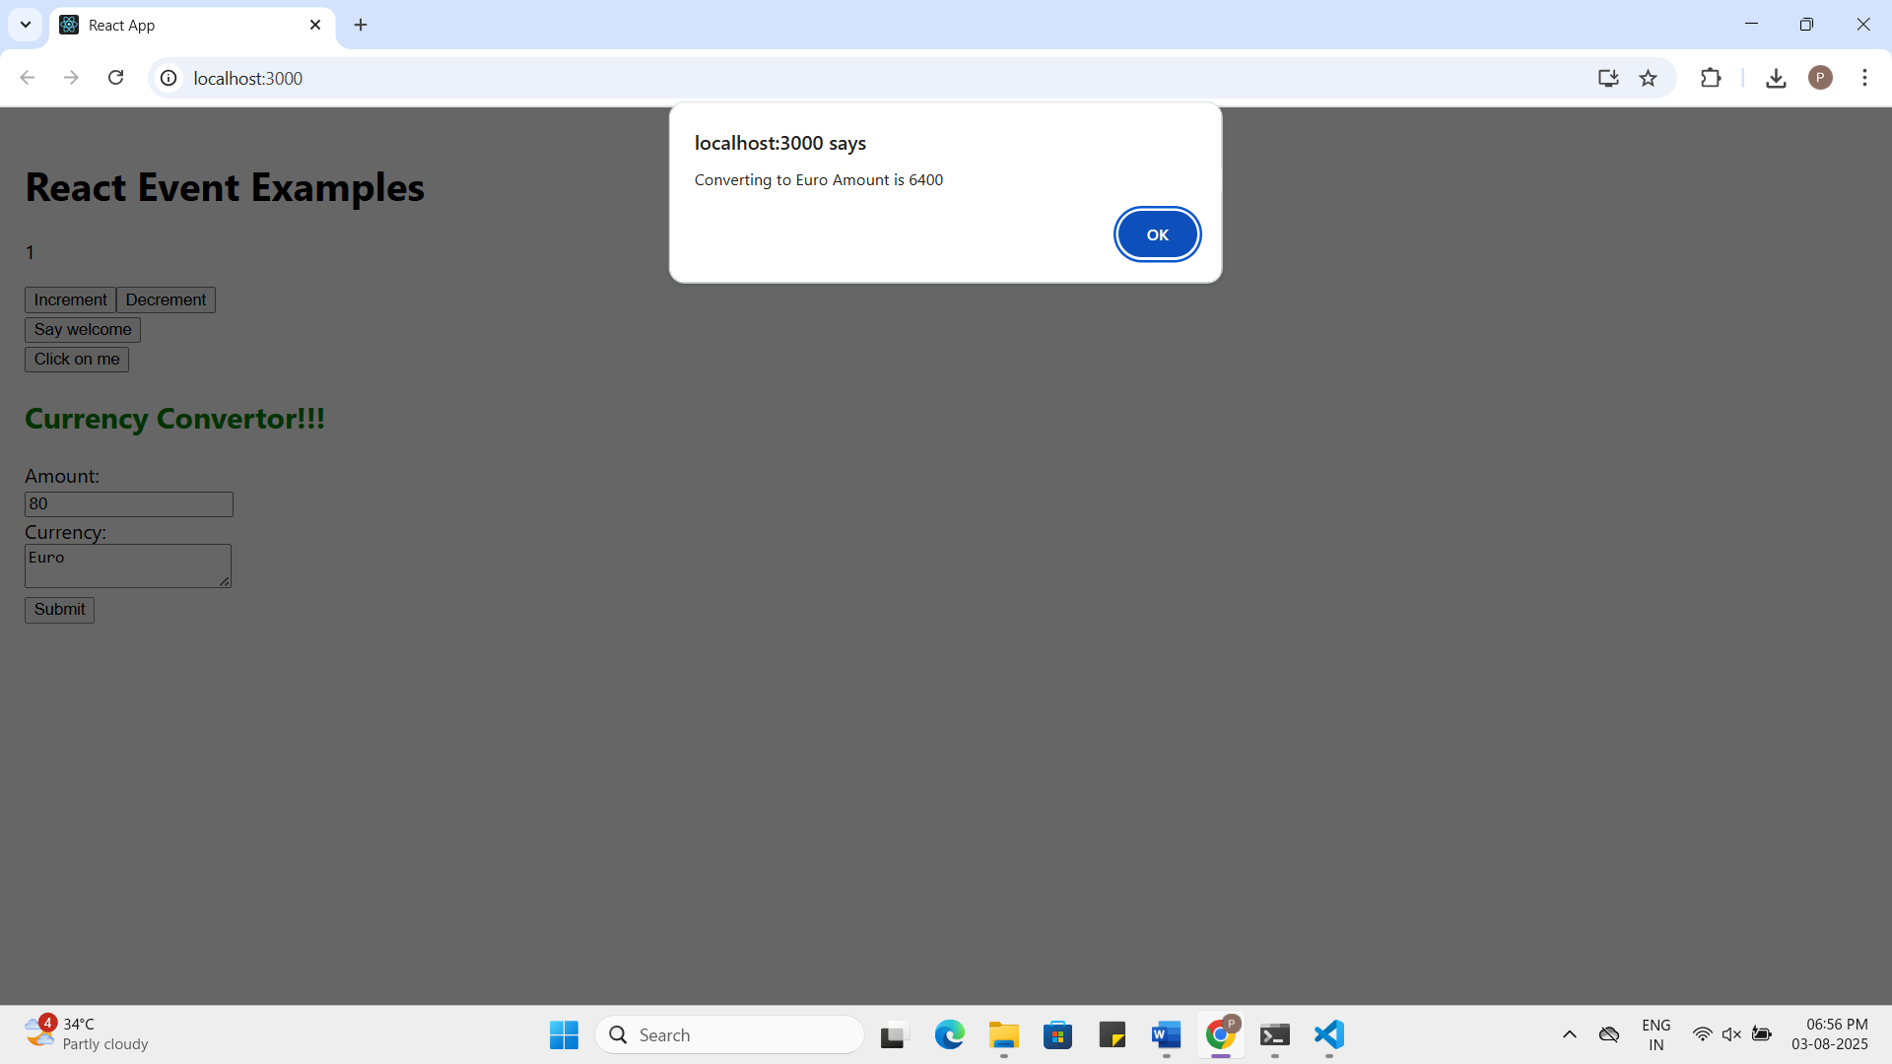

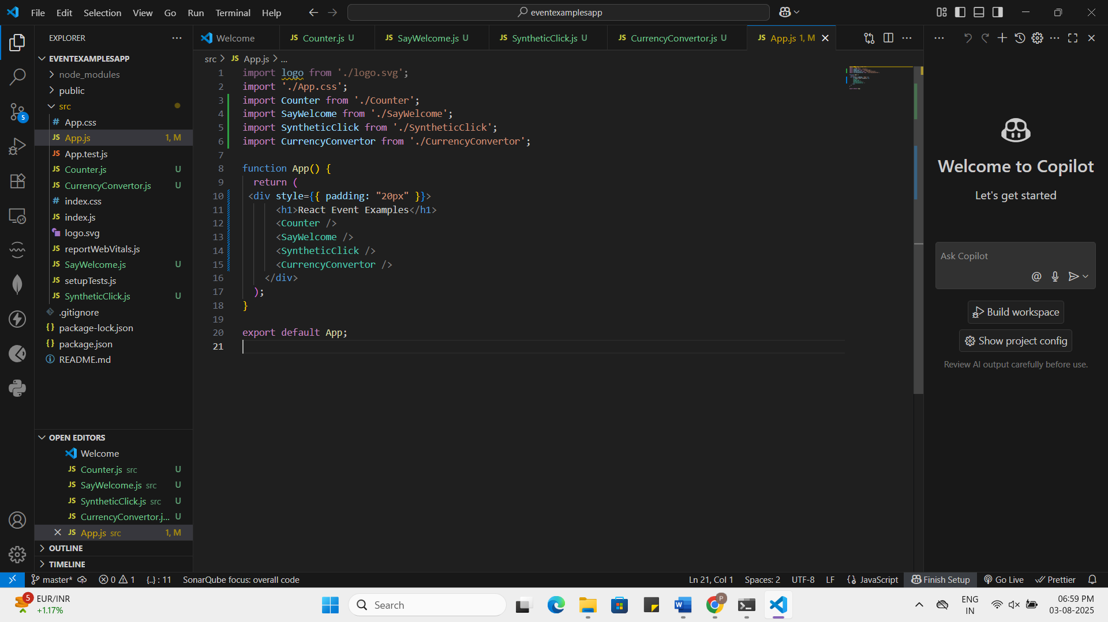

Counter.js:

import logo from './logo.svg';
import './App.css';
import Counter from './Counter';
import SayWelcome from './SayWelcome';
import SyntheticClick from './SyntheticClick';
import CurrencyConvertor from './CurrencyConvertor';

function App() {
return (
<div style={{ padding: "20px" }}>
<h1>React Event Examples</h1>
<Counter />
<SayWelcome />
<SyntheticClick />
<CurrencyConvertor />
</div>
);
}

export default App;

SayWelcome.js:

import React from 'react';

function SayWelcome() {
const handleWelcome = (message) => {
alert(message);
};

return (
<div>
<button onClick={() => handleWelcome("welcome")}>Say welcome</button>
</div>
);
}

export default SayWelcome;

SyntheticClick.js:

import React from 'react';

function SyntheticClick() {
const handleClick = (event) => {
alert("I was clicked");
console.log("Synthetic event object:", event);
};

return (
<div>
<button onClick={handleClick}>Click on me</button>
</div>
);
}

export default SyntheticClick;

CurrencyConvertor.js:

import React, { useState } from 'react';

function CurrencyConvertor() {
const [amount, setAmount] = useState('');
const [currency, setCurrency] = useState('');

const handleSubmit = (e) => {
e.preventDefault();
if (currency.toLowerCase() === 'euro') {
const result = amount * 80;
alert(`Converting to Euro Amount is ${result}`);
}
};

return (
<div>
<h2 style={{ color: 'green' }}>Currency Convertor!!!</h2>
<form onSubmit={handleSubmit}>
<label>Amount:</label><br />
<input
type="number"
value={amount}
onChange={(e) => setAmount(e.target.value)}
/><br />
<label>Currency:</label><br />
<textarea
value={currency}
onChange={(e) => setCurrency(e.target.value)}
/><br />
<button type="submit">Submit</button>
</form>
</div>
);
}

export default CurrencyConvertor;

12.ReactJS-HOL HandsOn
Question:
Create a React Application named “ticketbookingapp” where the guest user can browse the page where the flight details are displayed whereas the logged in user only can book tickets.
The Login and Logout buttons should accordingly display different pages. Once the user is logged in the User page should be displayed. When the user clicks on Logout, the Guest page should be displayed.
Answer:
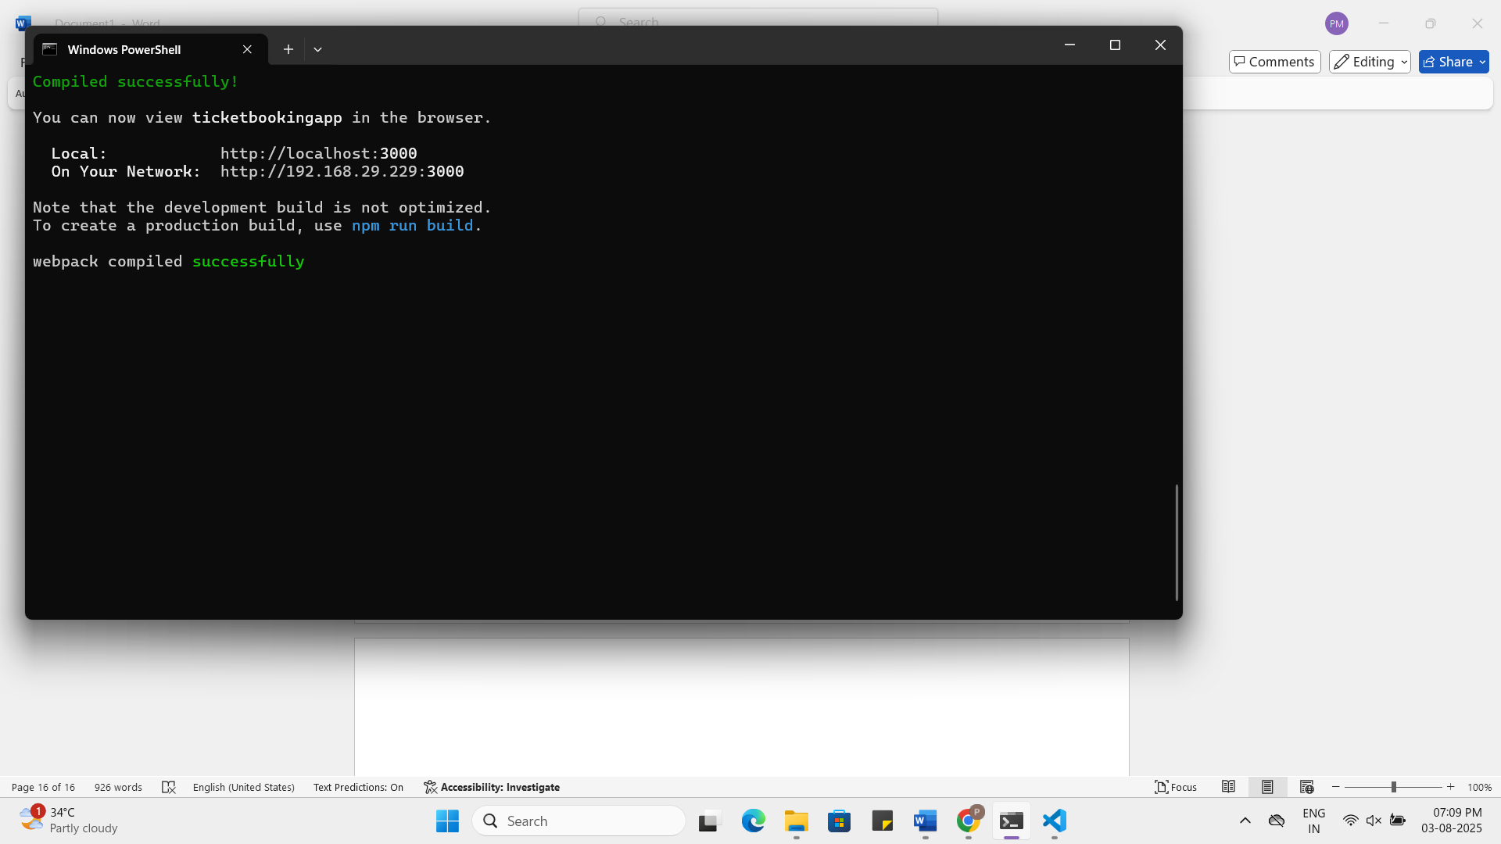

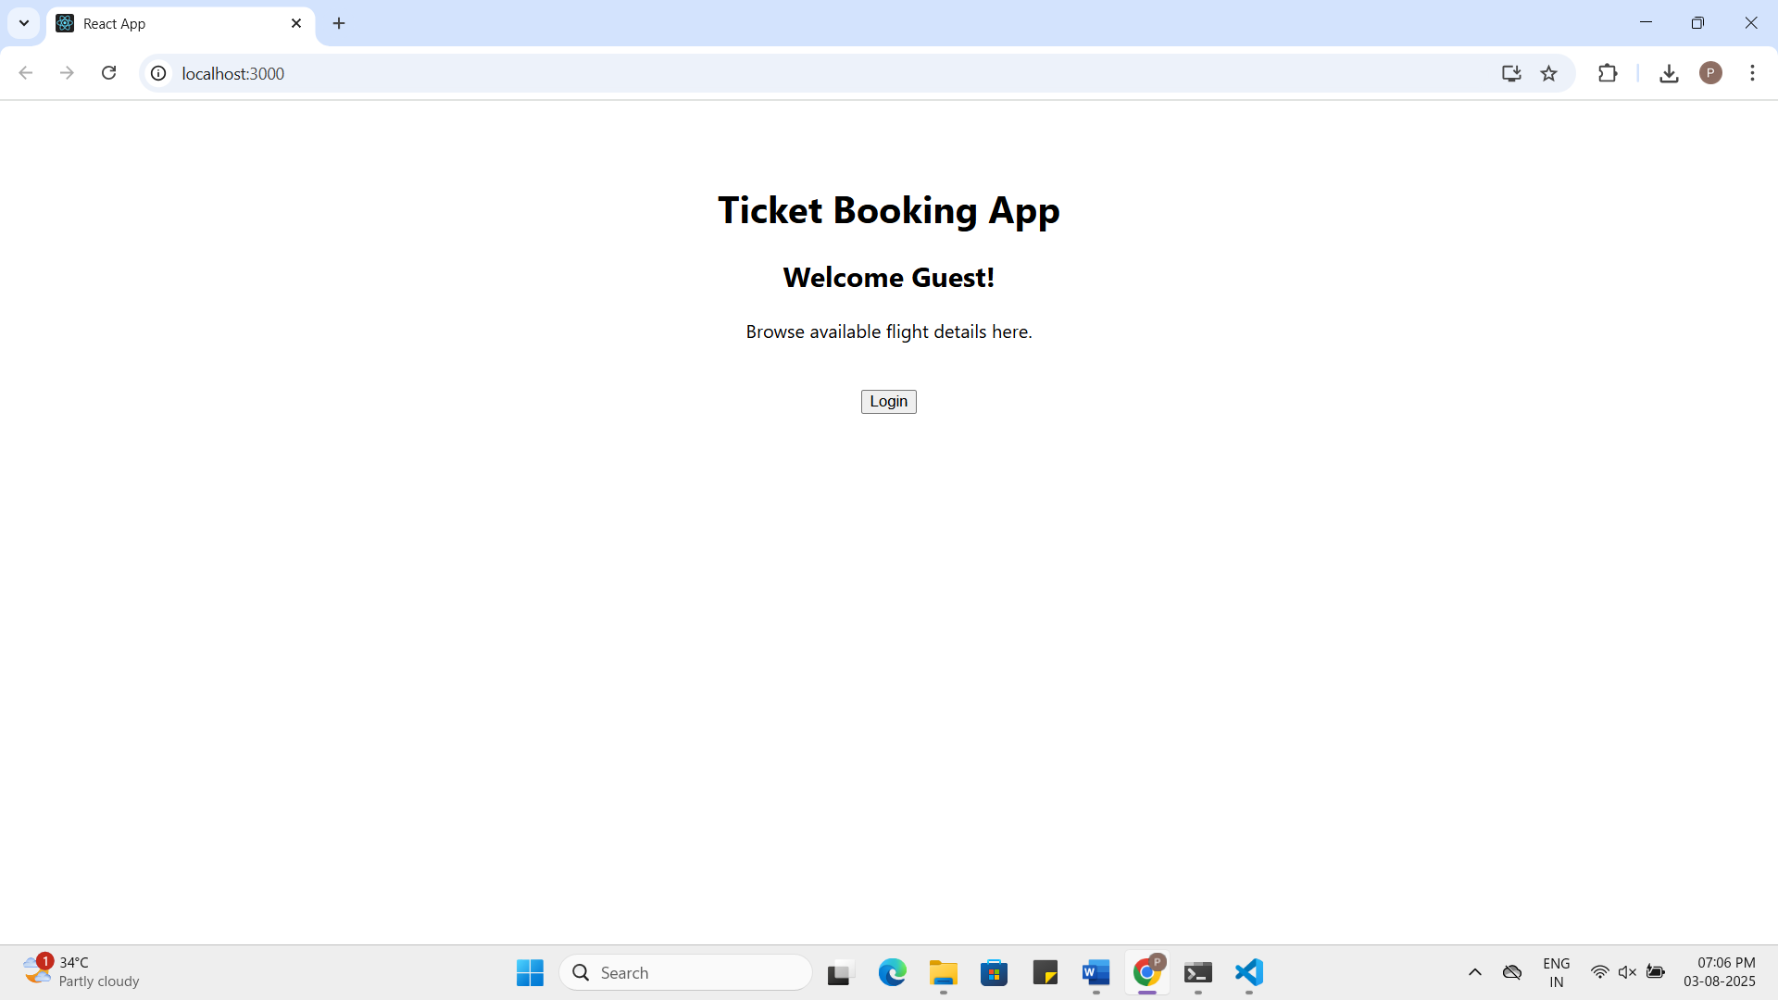
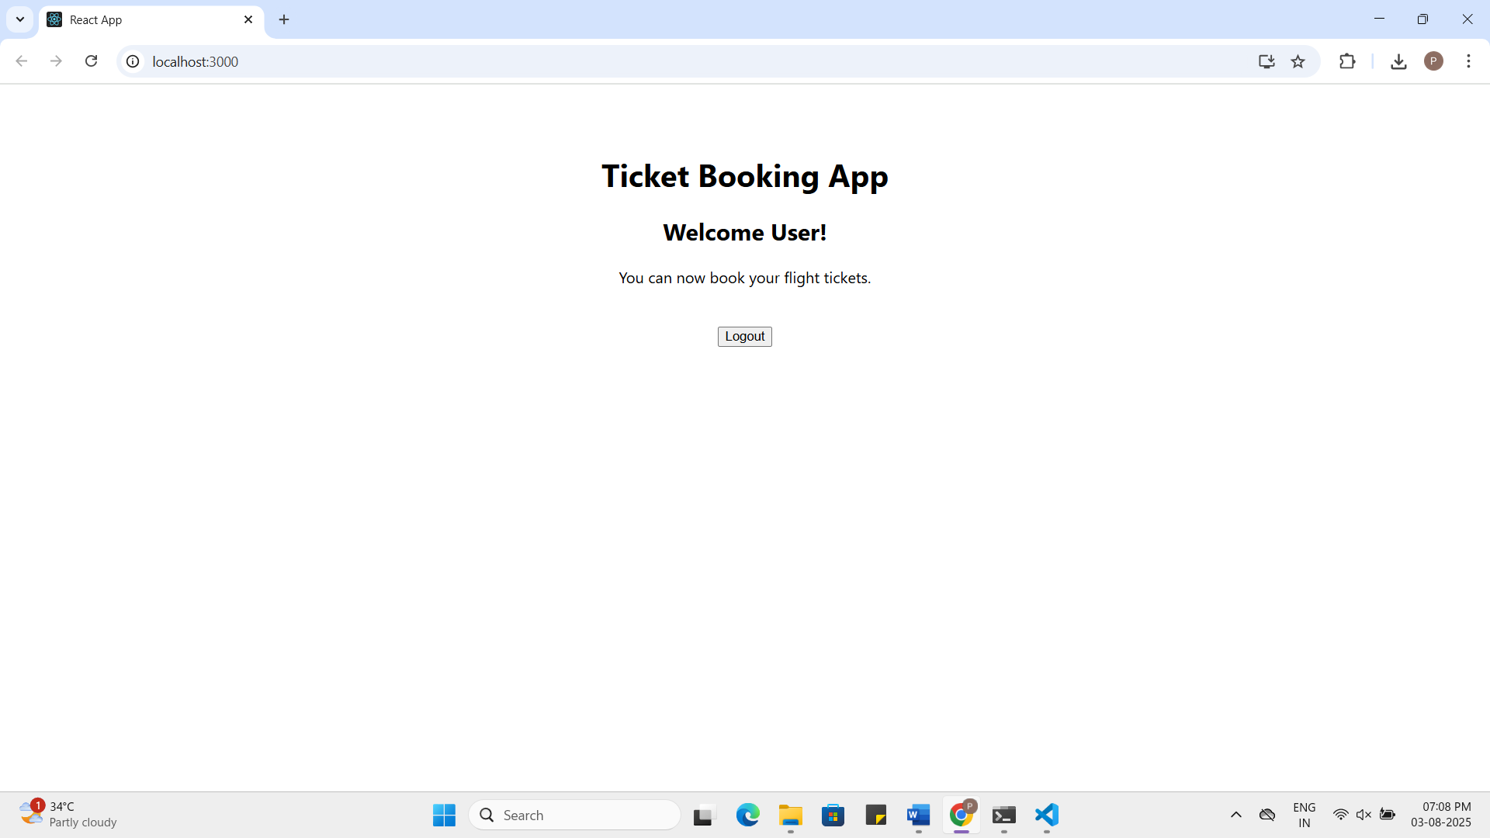

App.js:
import React, { useState } from 'react';

function GuestPage() {
return (
<div>
<h2>Welcome Guest!</h2>
<p>Browse available flight details here.</p>
</div>
);
}

function UserPage() {
return (
<div>
<h2>Welcome User!</h2>
<p>You can now book your flight tickets.</p>
</div>
);
}

function App() {
const [isLoggedIn, setIsLoggedIn] = useState(false);

const handleLogin = () => setIsLoggedIn(true);
const handleLogout = () => setIsLoggedIn(false);

return (
<div style={{ textAlign: 'center', padding: '50px' }}>
<h1>Ticket Booking App</h1>

{isLoggedIn ? <UserPage /> : <GuestPage />}

<br />
{isLoggedIn ? (
<button onClick={handleLogout}>Logout</button>
) : (
<button onClick={handleLogin}>Login</button>
)}
</div>
);
}

export default App;

13.ReactJS-HOL HandsOn
Question:
Create a React App named “bloggerapp” in with 3 components.
- Book Details
- Blog Details
- Course Details
Implement this with as many ways possible of Conditional Rendering.
Answer:
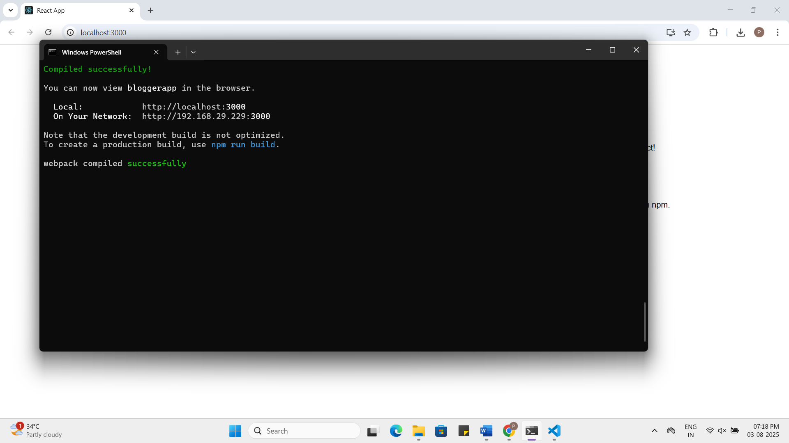

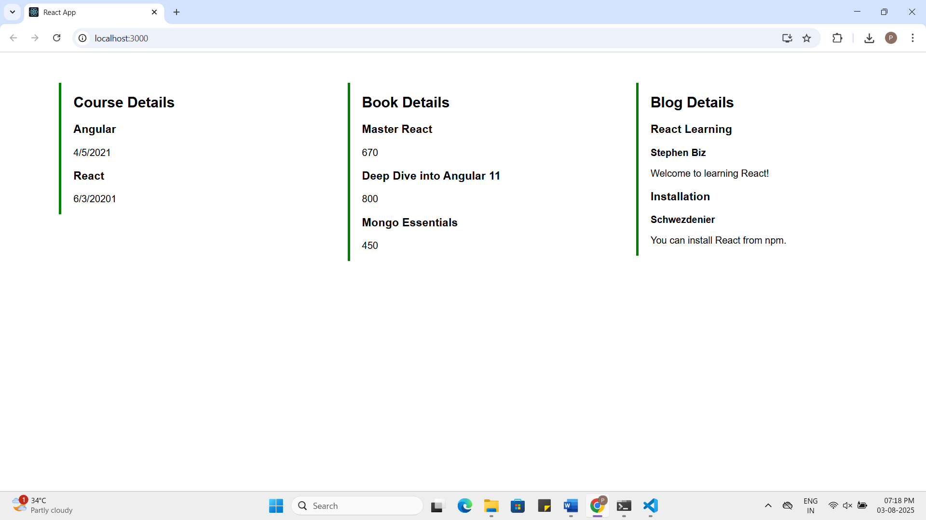
BookDetails.js:
function BookDetails() {
return (
<div className="card">
<h2>Book Details</h2>
<h3>Master React</h3>
<p>670</p>
<h3>Deep Dive into Angular 11</h3>
<p>800</p>
<h3>Mongo Essentials</h3>
<p>450</p>
</div>
);
}
export default BookDetails;
BlogDetails.js:
function BlogDetails() {
return (
<div className="card">
<h2>Blog Details</h2>
<h3>React Learning</h3>
<strong>Stephen Biz</strong>
<p>Welcome to learning React!</p>
<h3>Installation</h3>
<strong>Schwezdenier</strong>
<p>You can install React from npm.</p>
</div>
);
}

export default BlogDetails;
CourseDetails.js:
function CourseDetails() {
return (
<div className="card">
<h2>Course Details</h2>
<h3>Angular</h3>
<p>4/5/2021</p>
<h3>React</h3>
<p>6/3/20201</p>
</div>
);
}
export default CourseDetails;
App.js:
import CourseDetails from './CourseDetails';
import BookDetails from './BookDetails';
import BlogDetails from './BlogDetails';
import './App.css';
function App() {
return (
<div className="container">
<CourseDetails />
<BookDetails />
<BlogDetails />
</div>
);
}
export default App;

